**Study of cleavage fracture in ferritic stainless steels**

**Part I: Development and characterization of model microstructures.**

Lucie JACQUETa,b,*, Nicolas MEYERb, Maximilien LIBERTb, Frédéric DE GEUSERa, Muriel BRACCINIa, Rafael ESTEVEZa, Marc MANTELa,b

a Univ. Grenoble Alpes, CNRS, Grenoble INP, SIMaP, 38000 Grenoble, France

b Research center, Ugitech, 73400 Ugine, France

* corresponding author : [lucie.jacquet@ugitech.com](mailto:lucie.jacquet@ugitech.com)

**Highlights :**

**Abstract:**

**Keywords:** (Maximum 6)

# Introduction

Four main families of grades make up the metallurgy of stainless steels: austenitic, martensitic, ferritic and duplex stainless steels. These families are distinguished by the nature of their major constituent phases. Austenitic stainless steels, enriched with chromium and nickel, are the most widely produced (around 75% of the world market [1]), and are appreciated for their mechanical properties (high ductility and strain hardenability, high resilience at low temperature) and their resistance to corrosion [1–3]. Ferritic steels, whose chromium content varies from 11 to 30%, have lower alloying element contents than austenitic steels, and do not contain nickel or only a residual content. In addition to their generally low cost, these steels have the particularity of being ferromagnetic, a necessary asset for the design of solenoid valves, for example, used in the automotive and household appliance fields. Ferritic grades can be an alternative to austenitic ones, some of them with very good corrosion resistance: AISI 444 (EN 1.4521) ferritic grade has a PREN (Pitting Resistance Equivalent Number) equivalent to that of AISI 316 austenitic grade. The major drawback of ferritic steels is their mechanical behavior strong dependence on temperature which causes mechanical brittleness at low temperatures for mild steels, and at room temperature for ferritic stainless steels [4–7]. Their production and uses are then limited because of brittle fracture.

The objective of this work is to understand the mechanisms that govern cleavage brittle fracture in ferritic stainless steels and to quantify the role of two microstructural parameters of major importance: precipitation and grain size. To achieve this goal, we have elaborated different microstructures to establish relations between precipitation and grain size and fracture properties. Two consecutive articles bring together the results of this research work. This first article focuses on the characterization of these microstructures resulting from the same base of chemical composition, namely 18% chromium and 2% molybdenum to ensure an entirely ferritic matrix at any temperature. The chemical compositions will be systematically expressed as a weight percentage. The carbon and nitrogen content is set at C + N ≈ 0.030%, which is a content accessible via current processing means with an AOD (Argon Oxygen Decarburization) [8]. The addition of titanium or niobium changes the nature, size and location of the carbides and nitrides, while carefully chosen heat treatments will vary the size of the grains to obtain six distinct microstructures. The second article brings together the mechanical characterizations (impact tests, tensile tests with smooth and notched axisymmetric specimens) and the description of the mechanisms that govern cleavage brittle fracture of the six microstructures.

During cooling, precipitation of chromium carbides and nitrides [9] in ferritic stainless steel is due to the drastic decrease of carbon and nitrogen solubility limit in ferrite. The second factor which inevitably leads to the precipitation of Cr2N nitrides and (Cr,Fe)23C6 carbides is the high diffusion rate of the interstitial elements in the ferritic structure. Thus, even during a hyperquenching, this precipitation cannot be avoided contrary to what is observed in austenitic stainless steels. These precipitates germinate intra or intergranularly depending on the cooling conditions: inside the grains for high cooling rates and at the grain boundaries for lower cooling rates [10]. This precipitation has an embrittlement effect [11] and causes sensitization of grain boundaries to intergranular corrosion due to local chromium depletion on either side of the grain boundary. Ductility and corrosion resistance can be restored by an annealing heat treatment between 750 and 900 °C during which the carbides and nitrides coalesce and the chromium content is homogenized in the ferrite grains [12]. The precipitation of chromium carbides and nitrides can also be avoided by adding a sufficient amount of stabilizing elements such as titanium and niobium, that have a greater affinity with carbon and nitrogen than chromium. The intragranular carbonitrides formed in this case, TiN, TiC, Nb(C,N), precipitate at a higher temperature than chromium carbides and nitrides [2,13]. Stabilization tends to limit the brittleness of ferritic grades [14] but over-stabilization can be harmful due to the precipitation of intermetallic phases [15], [16]. During the production of these steels, deoxidation and desulphurization reactions take place to avoid inclusions of oxides and sulphides. However, very low contents of these elements remain (<0.010%) and inclusions of lime silicoaluminate oxides and manganese sulphides are observed in practice.

Other phases can also form and lead to embrittlement, such as intermetallic phases of sigma, chi or alpha prime type [1,16]. However, the kinetics of formation of these phases is relatively slow in ferritic steels and these intermetallic phases are not encountered following recrystallization heat treatments or even during welding operations. They will therefore not be studied in this work. The state of precipitation in steels stabilized with titanium and/or niobium is well described in the literature [17] : as long as the quantity of stabilizers is sufficient, all the carbon and nitrogen precipitate in the form of carbonitrides of titanium and niobium. In unstabilized grades, the chemical composition and crystallography of chromium carbides and nitrides are clearly identified, but no study indicates whether carbon and nitrogen completely precipitate in the ferritic matrix following hyperquenching. Indeed, the quantitative characterization of this fine precipitation, the size of which can be nanometric, is complex and requires heavy means of investigation. In this first article, we explain our choices of chemical compositions and thermomechanical treatments to develop the six model microstructures for which only the precipitation and/or the size of the grains from laboratory flows vary. We characterize the three microstructures stabilized with titanium or niobium and the three unstabilized microstructures using increasingly powerful tools to quantify grain size and study precipitation: optical microscopy (OM), scanning (SEM) and transmission (TEM) electron microscopies, small-angle neutron scattering (SANS). We will then discuss the presence or absence of carbon and nitrogen in solid solution, depending on the temperature and duration of the heat treatment and the rate of cooling of the ferrite in unstabilized grades.

# Experimental methods

## Development of the studied microstructures

To study the brittle fracture of stainless steels with a 100% ferritic matrix, the first step is to develop model materials. We have the possibility of working with laboratory casts for which the chemical composition is chosen and allows to vary only one element to study its influence. To ensure a ferritic structure from solidification and at any temperature, Figure 1 shows that 18% chromium is sufficient for a carbon content of 0.03%. 2% of molybdenum, an alpha-gene element, are also added to approach the chemical composition of AISI 444 industrial cast (18Cr-2Mo stabilized with Ti and Nb).

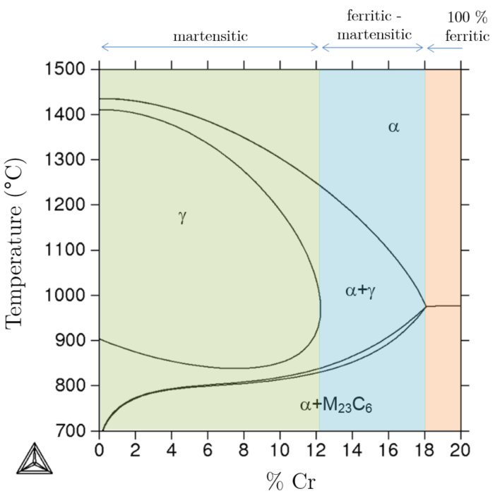

Figure 1 : Isopleth section of the Fe-xCr-0.3Si-0.3Mn-0.03C system calculated with ThermoCalc software and the TCFE6 database.

Six microstructures are made from three different grades: one stabilized with titanium, one stabilized with niobium and the last unstabilized. The carbon and nitrogen contents are kept constant for all the grades with a value of C + N ~ 0.030%. The Ugitech Research Center (CRU) is able to produce ingots of 25 kg of metal, with a square section of 10 x 10 cm², in a VIM (Vaccum Inuduction Melting) furnace. In order to produce enough metal for the study, five ingots were elaborated: Ti1 for the titanium stabilized grade, Nb1 and Nb2 for the niobium stabilized grade and Cr1 and Cr2 ingots for the unstabilized grade. The very similar chemical compositions of Nb1 and Nb2 ingots as well as Cr1 and Cr2 ones allow us to consider that this is the same alloy.

|  |  |  |  |  |  |  |  |  |  |  |  |  |  |  |  |
| --- | --- | --- | --- | --- | --- | --- | --- | --- | --- | --- | --- | --- | --- | --- | --- |
| Ferritic grades | Heat | Microstructure | Si | Mn | Ni | **Cr** | **Mo** | S  (ppm) | P (x103) | Al (x103) | O (ppm) | **C** (x103) | **N** (x103) | **Ti** | **Nb** |
| Titane stabilized | Ti1 | *Ti* | 0.42 | 0.47 | 0.01 | **17.9** | **2.01** | 16 | 2 | 13 | 61 | **13** | **17** | **0.19** | **X** |
| Niobium stabilized | Nb1 | *Nb* | 0.52 | 0.51 | 0.01 | **18.1** | **2.02** | 17 | 3 | 18 | 93 | **14** | **17** | **X** | **0.24** |
| Nb2 | *NbG* | 0.51 | 0.51 | 0.01 | **18.0** | **2.02** | 18 | 3 | 22 | 104 | **16** | **16** | **X** | **0.24** |
| unstabilized | Cr1 | *Cr*, *Cr0* | 0.48 | 0.49 | 0.01 | **18.0** | **2.03** | 10 | 3 | 14 | 87 | **12** | **17** | **X** | **X** |
| Cr2 | *CrP* | 0.50 | 0.50 | 0.01 | **18.0** | **2.02** | 17 | 2 | 23 | 105 | **15** | **15** | **X** | **X** |

Table 1 : Composition of laboratory casts

The titanium and niobium contents were chosen to trap all the carbon and nitrogen, but without excess in order to avoid the presence of intermetallic compounds. The values ​​of titanium and niobium weight percentages are given by equation 1 with the molar mass of the element and considering that the carbides and nitrides of titanium and niobium are perfectly stoichiometric: TiN, TiC and Nb(C,N).

To obtain the six model microstructures, we performed a range of thermomechanical treatments on the grade stabilized with titanium (Ti1 ingot), two different ranges on the grade stabilized with niobium (Nb1 and Nb2 ingots) and three different ranges of thermomechanical treatments on the unstabilized grade (Cr1 and Cr2 ingots) in order to vary and control precipitation and grain size. These ranges of thermomechanical treatments consist of forging ingots into bars, a heat treatment at 1050 °C, a cold rolling step and then one or two final heat treatments; these steps will be detailed later. The ingots are forged in 40 mm x 20 mm section bars in order to break the solidification structure and allow their cold rolling with a roller mill available at the CRU. Following forging, the bars are cut in half lengthwise before undergoing a first heat treatment at 1050 °C for 15 minutes followed by water quenching. The purpose of this heat treatment is to reduce the structural differences between the edge and the core of the bar. Indeed, following forging, at the edge of the bar the grains are coarse and elongated while they are finer, recrystallized and equiaxed in the center. In addition, rapid cooling by water quenching limits the precipitation of chromium carbides and nitrides, dissolved back into solid solution when maintained at 1050 °C. Following this first heat treatment, the bars are deformed by cold rolling. Between each rolling pass, the bars are a quarter turned to reduce the square section from 19x19 mm² to 12.5x12.5 mm². Obtaining a square section is necessary for machining the impact and tensile specimen. The cold deformation, at a reduction rate of approximately 50%, facilitates the recrystallization of the grains during the final heat treatments. The final heat treatments depend on the microstructures. The Ti (Ti1 ingot), Nb (Nb1 ingot) and Cr (Cr1 ingot) microstructures are obtained via a recrystallization heat treatment at 1000 °C for 5 minutes followed by water quenching. The thermomechanical treatment range illustrated with Figure 2a constitutes our reference range in order to obtain a recrystallized fine-grained microstructure.

The NbG microstructure (Nb2 ingot) is obtained following a heat treatment in several phases: holding at 1250°C for 30 minutes to recrystallize and then grow the grains, followed by a cooling at 1000°C in 3 hours, followed by a hold for 30 minutes at 1000°C before water quenching (Figure 2 b). The aim of this heat treatment is to obtain a homogeneous grain growth, which necessitates the dissolution of niobium carbonitrides, and then to re-precipitate the Nb(C,N) in order to obtain the same precipitation as the one in the Nb microstructure. The Cr0 microstructure is obtained following a final heat treatment, post cold rolling, at 1050 °C for 10 minutes followed by water quenching (Figure 2 c). As we will see later in this article, coarse chromium carbides and nitrides are present in the Cr microstructure. Maintaining the final heat treatment of the Cr0 microstructure at 1050°C will avoid these coarse precipitates thanks to the complete re-solution of the chromium carbides and nitrides. Finally, the last microstructure, CrP, is obtained from the Cr microstructure with an additional treatment at 850 °C for 2 hours followed by water quenching (Figure 2 (d)). This latter heat treatment is chosen to completely precipitate carbon and nitrogen in the form of chromium carbides and nitrides.

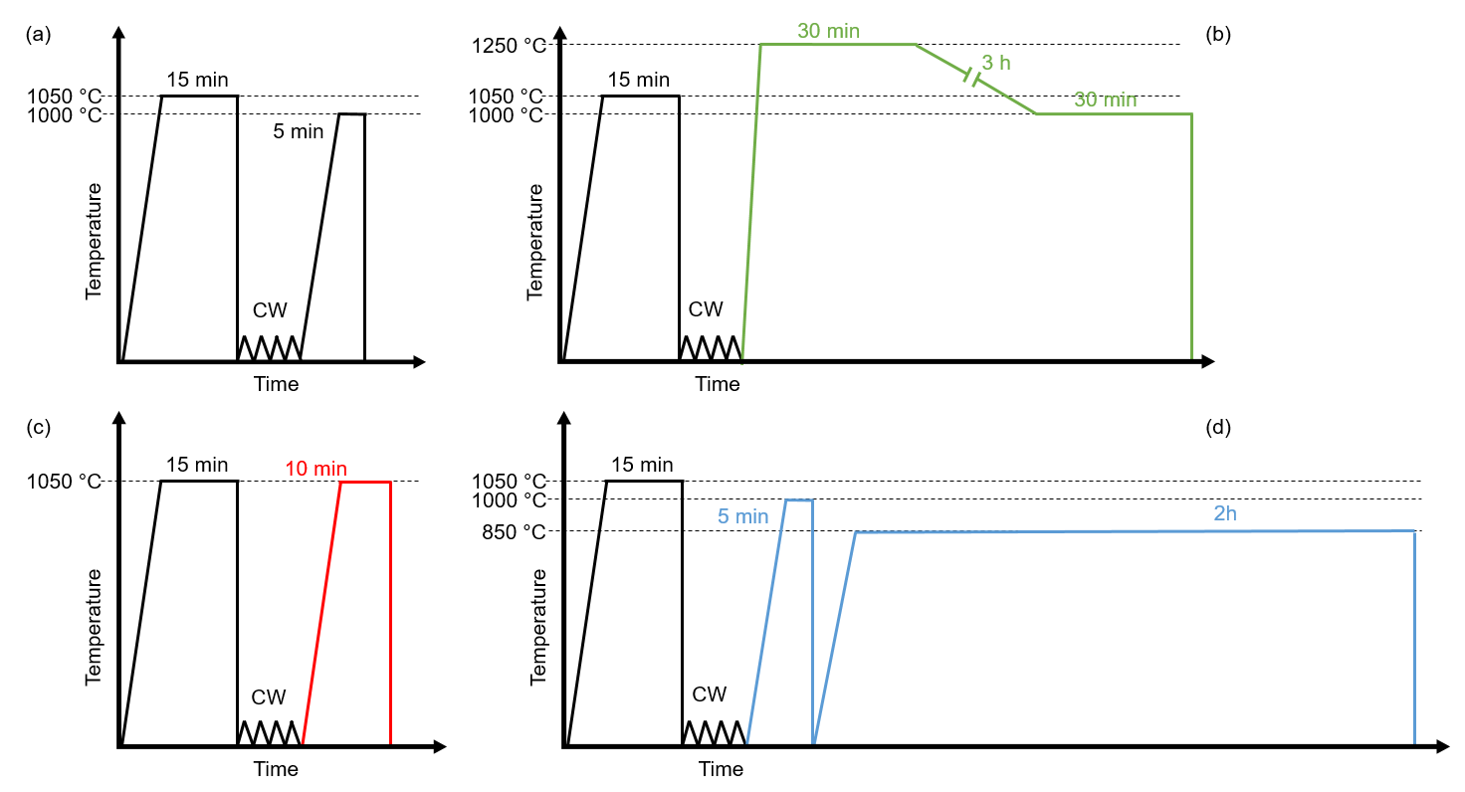

Figure 2 : Schematics of the thermomechanical treatments to obtain the six model microstructures: the Ti, Nb and Cr (a) model microstructures, the NbG microstructure (b), the Cr0 microstructure (c), the CrP microstructure (d)

The equilibrium phase diagrams obtained with the ThermoCalc software, given in Figure 3, indicate the expected phases, in addition to the ferrite, for each microstructure. In the Ti microstructure, the presence of nitrides, or even carbonitrides of titanium is shown (Figure 3a). In the Nb and NbG microstructures, only the presence of niobium carbonitrides is expected in addition to the ferrite (Figure 3b). For the CrP microstructure, maintaining at 850 °C must lead to massive precipitation of chromium carbides and nitrides, while heat treatments at 1 000 °C (Cr microstructure) and at 1050 °C (Cr0 microstructure) should possibly avoid this precipitation if water quenching is effective (Figure 3c). The precipitation obtained in the six microstructures will be described in the next section of the article.

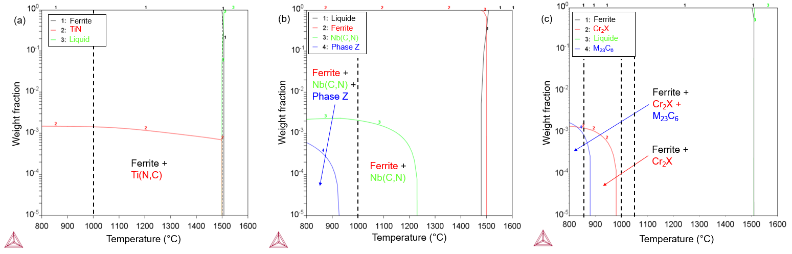

Figure 3 : Phase diagrams of grades stabilized with titanium (a) or with niobium (b) or unstabilized (c) obtained with the TCFE10 base from Thermo-Calc software

## Tools for microstructural characterizations

Grain size was measured by typical image method following the ASTM E112 standard after surface polishing and color attack etching of the samples. For this etching, the sample is immersed for 10 to 30 seconds in a solution heated to 70 °C and containing 110 ml of water, 12 ml of sulfuric acid, 4 ml of hydrofluoric acid and 5 to 6 drops of nitric acid. This attack grows an oxide film on the surface, and generates different color under polarized light according to crystal orientation. Grains which have a close orientation appear in similar colors. In addition, a homogeneous color in a grain is a sign that the grain is fully recrystallized. To observe the precipitation under optical and scanning electron microscopes, the surface is prepared with Vilella etching or simple polishing. Two scanning electron microscopes were used; the MEB JEOL 7000 AF from the CRU and the MEB FEG ZEISS GeminiSEM 500 from the Consortium of Common Technological Means (CMTC) of Grenoble INP. The qualitative observation of precipitation is supplemented by EDS (Energy Dispersive X-ray Spectroscopy) analyzes. The quantitative analysis of the precipitation of the stabilized microstructures was carried out at the CRU; a large number of images were analyzed using automation of image capture and processing. Figure 4 illustrates the steps in image processing: two threshold values were set ​​for the Nb and NbG microstructures to separate the oxides from niobium carbonitrides and a single threshold value for the Ti microstructure (because oxides are at the center of titanium carbonitrides). The nature of the particles counted is verified thanks to an EDS point analysis at the center of mass of each of them.

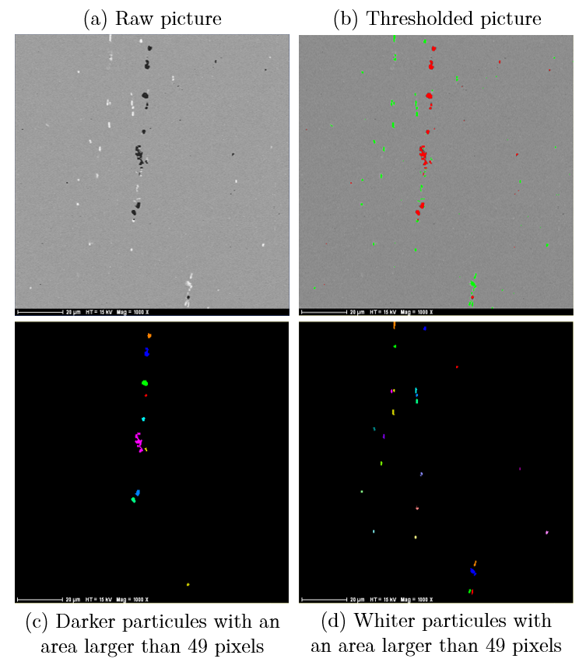

Figure 4 : example of the automatic processing of the SEM image in backscattered electrons mode (a) to quantify size of oxides, particles darker than the matrix (c) and niobium carbonitrides, particles lighter than the matrix (d) in the Nb microstructure in the long direction.

The conditions for acquiring the images and their processing are given in Table 2. More than 10,000 particles were quantified for each stabilized microstructure.

|  |  |  |  |  |
| --- | --- | --- | --- | --- |
| Microstructure | Ti | Nb | | NbG |
| Direction | Transversal | Transversal | Rolling | Transversal |
| Magnification | 500 | 800 | 1000 | 500 |
| Number of fields | 750 | 1800 | 2504 | 750 |
| Field size (px²) | 1024 x 1024 | 1024 x 1024 | 1024 x 1024 | 1024 x 1024 |
| Analyzed area (mm²) | 42.6 | 39.9 | 35.5 | 42.6 |
| Minimum area of a particule to be counted (px) | 15 | 20 | 50 | 15 |
| Minimum area of a particule of have an equivalent diameter ≥ 1µm | 15 | 38 | 59 | 15 |

Table 2: Experimental conditions for quantitative automatic SEM analyzes

Two transmission electron microscopes were used to characterize the precipitation of unstabilized microstructures: FEG JEOL 2100F 200 keV TEM at CRU and at CMTC. Classically prepared replicas and thin sections were observed in addition to a thin section of the Cr0 microstructure prepared by FIB SEM. Finally, we characterized the finest objects of the studied microstructures by central small angle neutron scattering (SANS) on the D11 line of the Laue Langevin Institute (ILL). 3 mm thick wafers have been prepared for this purpose. The reader may refer to the work of [18] for more details on the sample preparation method and the SANS experiment. In our case, the wavelength of the neutron beam was set at λ = 5 Å ± 0.5 Å and we varied the distance between the sample and the detector from 2.5 m to 20 m to cover a wide range of diffusion vector q. The intensity collected is the sum of two components: magnetic and nuclear. Each has been fitted by the equation (1) in which the first term on the right hand side refers to the behavior of Porod, the second term L describes the inconsistent component of the signal that forms a "baseline". The third term depends on the size of the particles R assumed to be spherical, the size distribution of the particles (chosen Schulz distribution of width s = 0.3), the volume fraction of particles fv and the contrast (magnetic or nuclear) ∆ρ.

|  |  |
| --- | --- |
|  | (1) |

Moreover, corresponds to the area under the curve Iq² as a function of q. It is determined in order to estimate in the next section of this article.

# Results

## Grain structure

The grains of the six model microstructures are recrystallized and equiaxed from the edge to the center of the bar (Figure 5). The grains of the Ti, Nb, Cr and CrP microstructures have roughly the same size, with an average diameter of 70 µm. The grains in the NbG microstructure are ten times larger than the grains in the Nb microstructure. Holding at 1250 °C for 30 minutes, followed by a slow drop in temperature to 1000 °C had the desired effect. Note that the grains in the Cr0 microstructure are also relatively larger; their average diameter is about three times greater than that of the grains in the Cr and CrP microstructures. Maintaining at 1050 °C for 10 minutes allowed the dissolution of the chromium carbides and nitrides, as we will see below, but had free the grain boundaries from their pinning.

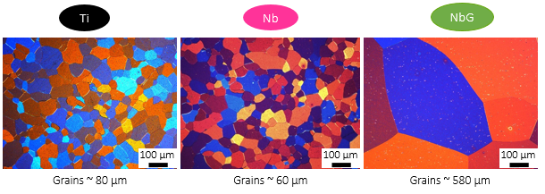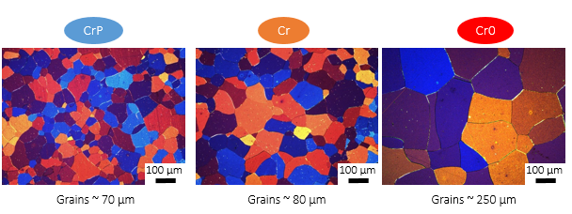

Figure 5 : Grains of the six model microstructures in transverse direction under a polarized light microscope (coloring attack).

## Precipitation in the stabilized microstructures

In the Ti microstructure, particles visible at low magnification are homogeneously distributed in the ferrite grains. With SEM observation and EDS analysis, the chemical elements of these particles are identified: the nucleus is rich in Al and O while the envelope is enriched in Ti (Figure 6). Note that these particles have particular shapes, with salient angles. At higher magnification, Figure 7 reveals the outer envelope of the compounds, rich in Mo and the presence of a fine precipitation rich in titanium distributed in the ferritic matrix. The compounds rich in Al and O are oxides that precipitate in the liquid metal and serve as nucleus sites for titanium nitrides TiN. TiN are then enveloped by titanium carbides (Ti, Mo) C which precipitated at lower temperatures.

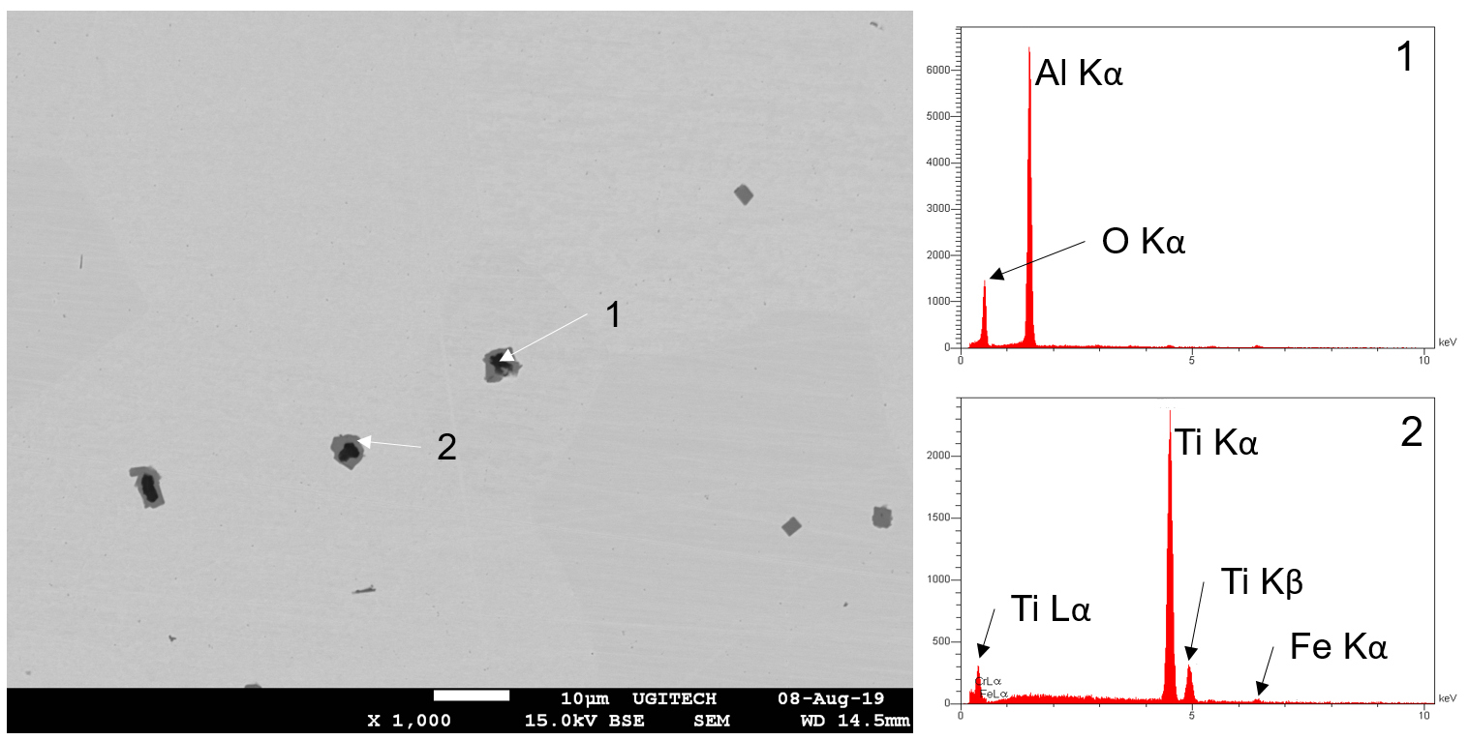

Figure 6 : (left) Backscattered electron (BSE) mode SEM image on Ti microstructure (magnification x1000, OPS finish). (right) EDS point analyses on the two phases which constitute the complex particles.

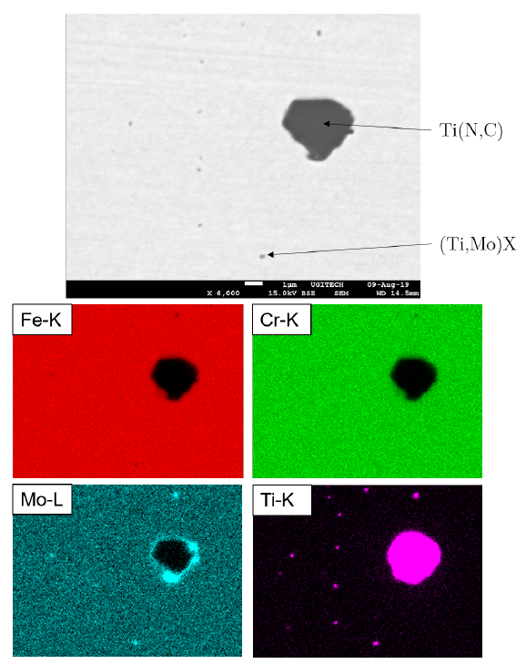

Figure 7 : (top) left) Backscattered electron (BSE) mode SEM image on Ti microstructure in the long direction and (bottom) X ray mapping at 15 kV (simple polishing). Note that the intensity scale of the spectrum corresponding to the Ti-K line is greatly expanded to reveal the presence of Ti in the fine particles.

The two microstructures stabilized with niobium, Nb and NbG, present a distributed homogeneous intragranular precipitation, visible on the SEM images in Figure 8. An EDS analysis, illustrated for the Nb microstructure in Figure 9, allowed to identify two types of particles: oxides which appear darker than the matrix on the images in Figure 8 and niobium carbonitrides Nb (C,N) or (Nb,Mo) (C, N), enriched in molybdenum, lighter than the matrix. The uniformity of the silicon mapping and the absence of iron indicate that those precipitates are not Fe2Nb type intermetallics but Nb (C, N), which is consistent with the low niobium overstabilization of the grades (ΔNb (Nb1) = 0.023% and ΔNb (Nb2) = 0.020%). The observed precipitation is consistent with the expected equilibrium precipitation of the phase diagram (Figure 3). It is noted that niobium carbonitrides appear to be thicker in the NbG microstructure, which will be verified in the following section.

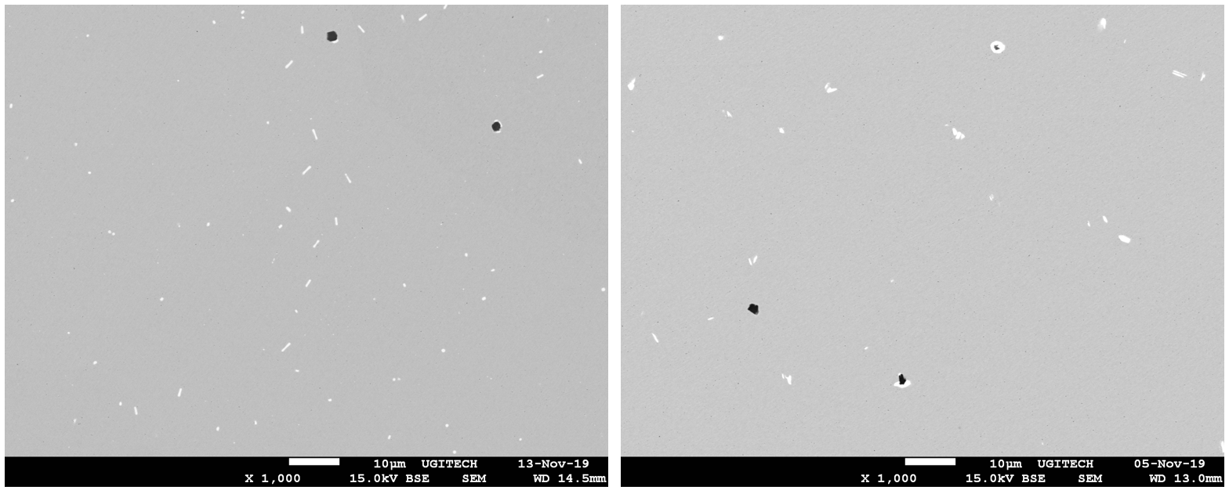

Figure 8 : Nb microstructures on the left and NbG on the right using SEM, images in backscattered mode, magnification x1000 (simple polishing).

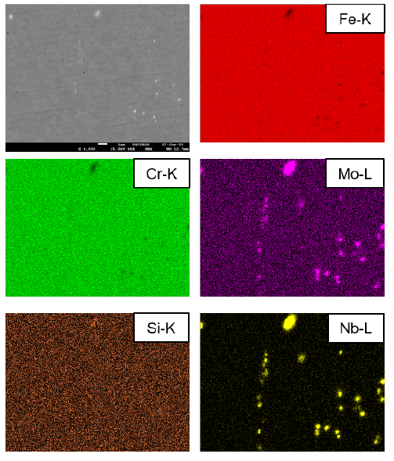

Figure 9 : Nb microstructure SEM image in backscattered mode and X ray mapping at 15 kV.

Thanks to quantitative SEM analysis particles size distribution can be obtained using their equivalent diameter. While niobium carbonitrides and oxides can be quantified separately in the Nb and NbG microstructures, for the Ti microstructure, titanium nitrides and oxides are not counted separately due to the fact that the oxides are circled by the titanium carbonitrides. The equivalent diameter histograms of niobium carbonitrides and oxides for Nb and NbG as well as oxide + TiN complex particles for the Ti microstructure are given in Figure 10. Only particles with an equivalent diameter greater than or equal to 1 μm are counted.

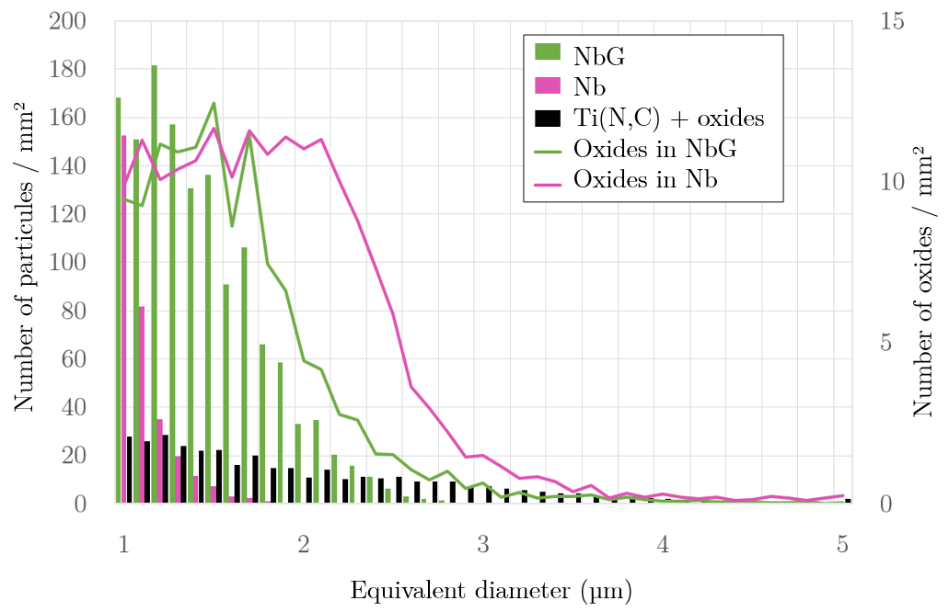

Figure 10 : Size distribution of the majority particles and of the oxides with an equivalent diameter greater than or equal to 1 µm for the Ti, Nb and NbG microstructures

Precipitation is different in Nb and NbG microstructures: the larger particles are more numerous in the NbG microstructure. During the temperature rise to 1250 °C, necessary to make the grains grow homogeneously, the Nb(C, N) dissolved back into solid solution but then re-precipitated during the cooling and hold at 1000 °C. The niobium carbonitrides of the Nb microstructure are smaller but more numerous. In the Ti microstructure, the precipitates are larger, their equivalent diameter being able to reach 4-5 μm, but they are less numerous than the niobium carbonitrides of the Nb and NbG microstructures. Finally, in these two microstructures, we note that oxides are the largest particles present although much less numerous. Indeed, the presence of oxygen between 50 and 100 ppm is inevitable in the castings despite deoxidation with aluminum and silicon. Our six model microstructures exhibit a similar population of oxides.

## Precipitation in unstabilized microstructures

In this part, we focus on the precipitation of the three microstructures CrP, Cr and Cr0 obtained from the unstabilized grade. Figure 11 allows a first comparison of the precipitation of these three microstructures. In the CrP and Cr microstructures, intra and intergranular precipitation are visible while at this magnification, no precipitate is visible in the Cr0 microstructure (apart from the oxides which are inclusions). In view of the recrystallization heat treatment of the Cr microstructure (hold at 1000 °C for 5 minutes followed by water quenching), the presence of micrometric carbides and nitrides of chromium is surprising and we explain it that way : carbides and nitrides precipitated during the rise in temperature and could not be completely dissolved back into solid solution during hold during a too short time and/or at a too low temperature. For the Cr0 microstructure, with a recrystallization treatment at 1050 °C for 10 minutes followed by rapid cooling by water quenching, the chromium carbides and nitrides formed during the rise in temperature were dissolved. Finally, the CrP microstructure exhibits numerous micrometric particles thanks to the heat treatment of precipitation at 850 °C for 2 h.

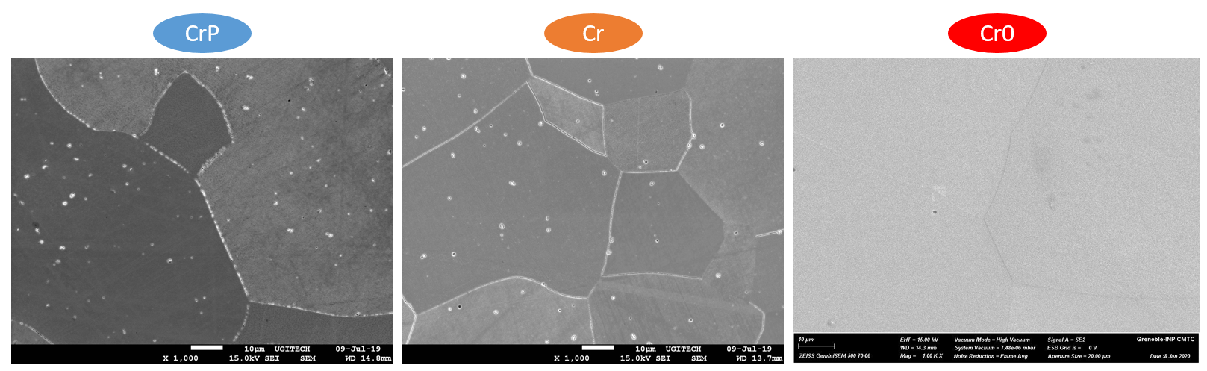

Figure 11 : Secondary electron (SE) mode SEM image of CrP, Cr and Cr0 (magnification x1000, Vilella attack).

TEM observations confirm the presence of micrometric M23C6 carbides and Cr2X nitrides in the CrP and Cr microstructures (Figure 12). In addition, Cr2X of around twenty nm are agglomerated at the grain boundaries in the Cr microstructure (image (d)) and in the Cr0 microstructure (images (c) and (e)). Finally, fine intragranular precipitates, of a few nm, were identified on a thin section for the Cr0 microstructure (image (f)).

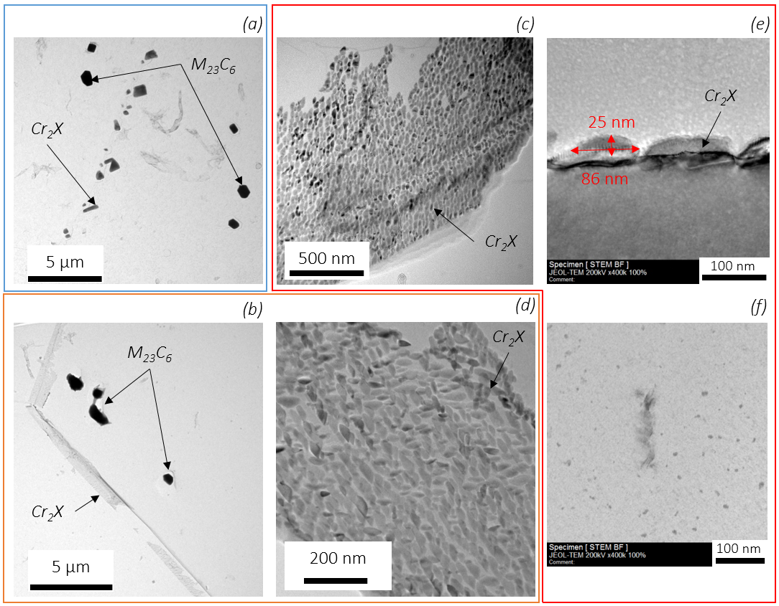

Figure 12 : TEM images on replica of CrP (a), Cr (b) and (d) and Cr0 (c) and (e). TEM image of Cr0 (f) microstructure on a thin section prepared with SEM-FIB.

Small-angle central neutron scattering (SANS) experiment at ILL complements the study of precipitation of unstabilized microstructures. SANS is sensitive to objects of size between few nm to hundreds of nm. In the CrP microstructure, no precipitation of size in this range has been detected, while in the Cr and Cr0 microstructures, objects with a radius of around ten nm are present (Figure 13). For the Cr0 microstructure, the quantified precipitation could be that observed with TEM on a thin intragranular section (Figure 12 (f)). The results of the SANS experiment will be interpreted in the next section.

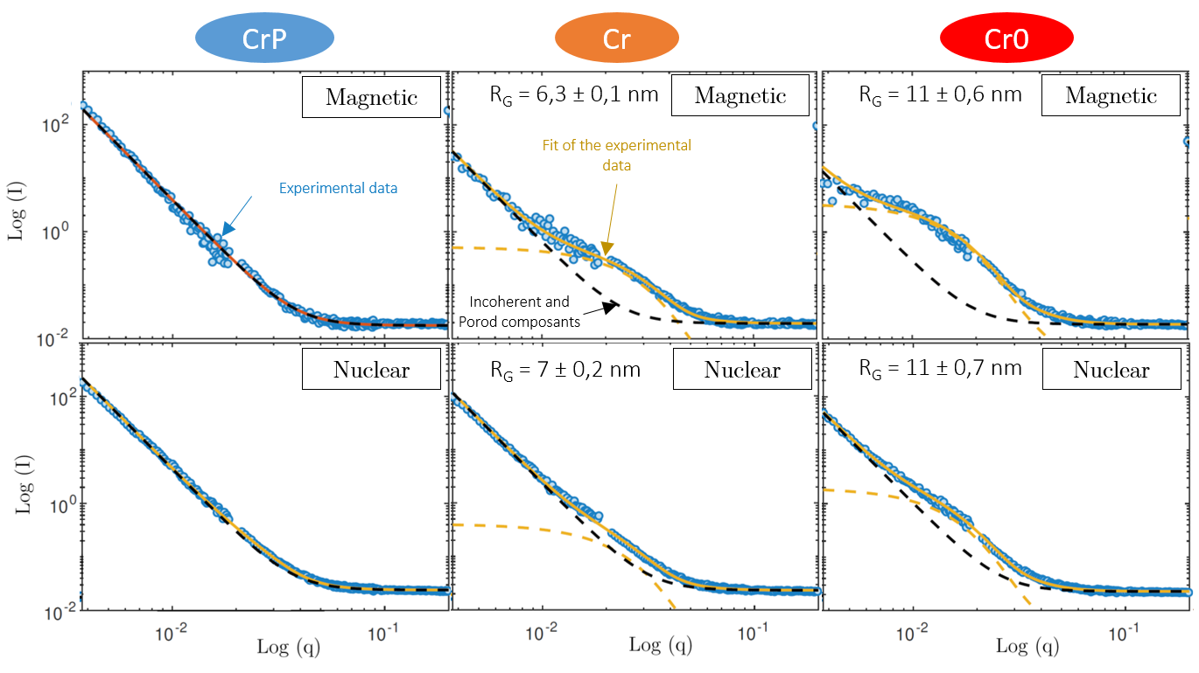

Figure 13 : Analysis of SANS data acquired on CrP, Cr and Cr0 microstructures

# Discussion

Of the three unstabilized microstructures, two have been water quenched from 1000 °C or more, temperature range where C and N are completely soluble in the ferrite (Figure 14). In this part, we discuss the presence of C and N in solid solution in ferrite at room temperature in the Cr and Cr0 microstructures obtained following water quenching. The Cr0 microstructure is chosen as an example.

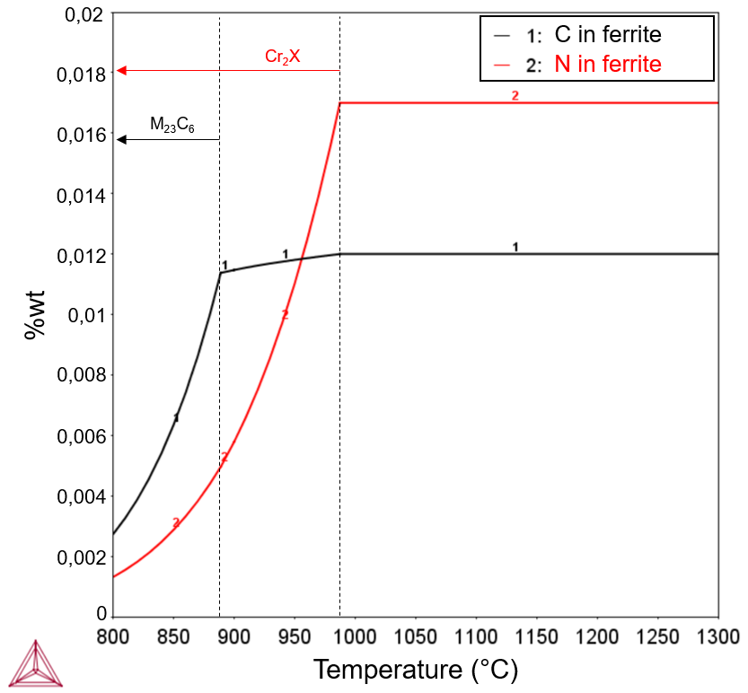

Figure 14 : Solubility limits of carbon and nitrogen in ferrite as a function of temperature for the composition of the Cr1 ingot, calculated with Thermo-Calc TCFE10 software.

## Theoretical volume fractions

Since cooling by water quenching is particularly rapid, the thermodynamic equilibrium for which et is certainly not reached. Figure 15 groups together the changes in the volume fractions of the three types of precipitate observed as a function of temperature for the metastable equilibrium (equilibrium between ferrite and one type of precipitate, excluding the other phases of the calculation). These fractions increase when the temperature decreases until they stabilize around 600 °C, a temperature which seems to constitute an upper limit for the fraction of precipitates with:

, and .

We will compare these theoretical volume fractions with experimentally measured fractions.

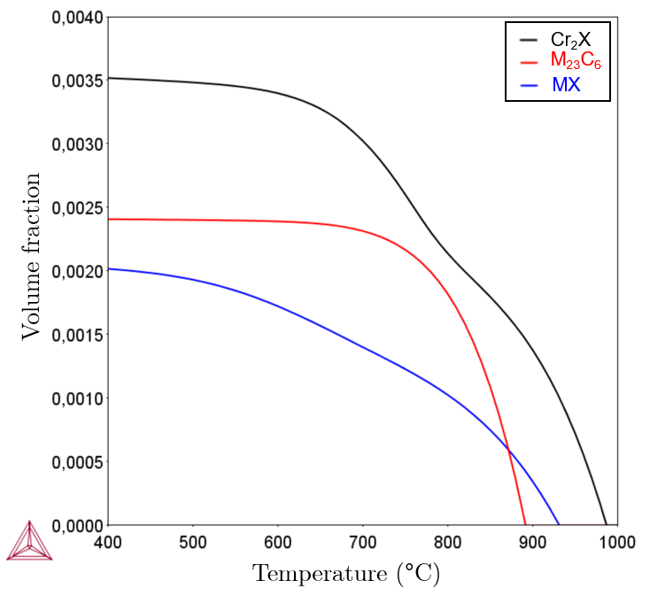

Figure 15 : Volume fraction of Cr2X, M23C6 or MX with temperature for metastable  equilibrium, Thermo-Calc TCFE10 software. Composition of heat Cr1.

## Volume fraction of precipitates quantified with SANS:

Intra and intergranular precipitates have been identified in the Cr0 microstructure thanks to TEM observations. In addition, using SANS, a fine precipitation was quantified with an unknown nature and location. These may be intragranular precipitates in Figure 12 (f), intergranular precipitates in Figure 12 (c), or precipitation not identified by TEM. To estimate the volume fraction of precipitates in the Cr0 microstructure, the volume fraction of intergranular precipitates observed with TEM and the volume fraction of precipitates quantified with SANS will be added. We made the assumption that the precipitates quantify with the SANS are not the intergranular precipitates because they might appear like a continuous film and not individual bodies to the neutrons beam. This means that if the intragranular precipitates observed with TEM are not the ones quantified with SANS, they are not quantified by this approach and then the total volume fraction of precipitates is underestimated.

To estimate the volume fraction of the quantified precipitates, the nuclear component and/or the magnetic component can be used. To use the magnetic component of the signal, the average magnetic moment of the precipitates must be known. According to [19], when the particles are composed of more than 70% of chromium, the average magnetic moment can be considered zero and . This assumption is valid if the quantified precipitates are (metal atoms contains more than 80% of chromium) but it is not verified if the precipitates are M23C6. In the latter case, we cannot evaluate . We therefore choose to estimate the volume fraction of the precipitates quantified thanks to the nuclear component of the signal. This requires assumptions about their composition. The objective is to determine the difference of nuclear contrast between the precipitates and the matrix in order to estimate from the intensity evaluated experimentally. We use the following equation:

|  |  |
| --- | --- |
|  | (2) |

The difference between the nuclear contrasts of the precipitates and the matrix is ​​given by the equation below with  :

|  |  |  |
| --- | --- | --- |
|  | | (3) |
|  | |  |
| With, | Mean nuclear diffusion length of precipitates () or the matrix () | |
|  | Atomic concentration of the chemical elements () | |
|  | Mean nuclear diffusion length | |
|  | Mean atomic volume of the precipitates, matrix or Fe | |
|  | Ratio of atomic volume of the precipitates and the matrix | |

The nuclear diffusion length of the chemical elements of the metal is calculated from the equation . The coherent nuclear diffusion cross section of each chemical element is the sum of the cross sections of each of its isotopes weighted by their rate of presence and given in the table 3. In practice, we will consider that because the precipitates and the matrix are constituted by the same atoms. The nominal composition of the matrix remains the same despite the precipitation of the particles. This assumption is valid for carbon and nitrogen because the nominal atomic composition of the matrix is ​​already very low compared to that of the particles formed. If tends to 0, the difference will be only slightly modified. For the other chemical elements present in the precipitates, the volume fractions of precipitates will be low enough to consider that the chromium and the iron which leave the matrix to enrich these particles do not modify the average content of the matrix sufficiently to have a significant influence. The next step in the interpretation of the analysis of the data acquired with SANS requires assumptions on the composition, and therefore on the nature of the precipitation studied. The precipitates likely to be present in unstabilized ferritic grades are chromium carbides M23C6, chromium nitrides Cr2X or M2X and MX where M denotes iron, chromium, molybdenum, titanium and X carbon and nitrogen. Table 3 shows the volume fractions obtained from of the Cr0 microstructure according to the hypothesis on the nature and composition of the particles studied. The iron, chromium, molybdenum and titanium contents are those measured in TEM by EDS on the observed precipitates. The precipitates quantified with neutrons may not have the same composition, but we assume that they are precipitates of the same nature. Since the carbon and nitrogen contents were not quantified by EDS, we estimated these volume fractions by assuming that there is no nitrogen in the M23C6 and that the carbon represents between 0 and 50% of the share of light elements in Cr2X and between 0 and 25% in MX, the rest being nitrogen.

|  |  |  |  |  |  |  |  |
| --- | --- | --- | --- | --- | --- | --- | --- |
| Particules | Fe | Cr | Mo | Ti | C | N | fv Cr0 (%) |
|  |  |  |  |  |  |  | 0,032 |
|  |  |  |  |  |  |  | 0,012 |
|  |  |  |  |  |  |  | 0,028 |
|  |  |  |  |  |  |  | 0,02 |
|  |  |  |  |  |  |  | 0,027 |
|  |  |  |  |  |  |  | 0,05 |
|  |  |  |  |  |  |  | 0,072 |

Table 3 : Assumptions about the nature and composition of precipitation quantified by SANS and associated volume fractions, determined from nuclear contrast, in the microstructure Cr0.

The volume fractions in Table 3 give an estimate of the actual volume fraction of the quantified precipitation. However, with the results of neutron scattering alone, it is impossible to statue on the precipitation hypothesis.

## Volume fraction of intergranular precipitates

The volume fraction of intergranular precipitates is estimated experimentally via TEM images before being verified by simulating the growth of a germ with DICTRA software. Fine precipitates agglomerated at grain boundaries are present in the Cr0 microstructure (Figure 12 (c) and (e)). The surface of these particles covers about 65% of the surface of the grain boundary. In order to estimate the volume fraction occupied by these particles we make the following assumptions: all the grain boundaries of the Cr0 microstructure are covered by this film of particles and, a single particle on average occupies the thickness of the intergranular film.

We estimate the volume fraction of particles at grain boundaries using the following equation:

|  |  |  |
| --- | --- | --- |
|  | | (4) |
|  |  | |
| With | Volume occupied by particles at grain boundaries | |
|  | Average volume of a grain | |
|  | Surface occupied by particles at grain boundaries | |
|  | Average thickness of particles at grain boundaries, equal to their equivalent diameter | |
|  | Number of particles in the gain boundary thickness, | |
|  | Grain average surface | |
|  | Surface fraction of particles at grain boundaries | |

The volume fraction of particles at the grain boundaries is thus estimated at 0.02% for the Cr0 microstructure assuming the intergranular particles are cylinders.

In the following, the results of thermodynamic precipitation calculations are joined together which will help us to check the volume fraction of particles at the grain boundaries which precipitated during the water quenching. The calculations were carried out with the Thermo-Calc software and the TCFE10 and MOBFE5 databases. The study of thermodynamic equilibrium reveals that Cr2X and M23C6 precipitate in the ferrite (Figure 3 (c)). The first step of our approach consists in calculating the driving force of each of these phases which appears in the denominator of the critical radius. Thus we will compare the probability of formation of Cr2X and of M23C6 with Figure 16. The Thermo-Calc calculation was carried out by considering three phases: ferrite, a solid solution of hexagonal structure which can describe the phase Cr2X (HCP_A3) and the phase M23C6. We have limited the chemical composition to the major elements, i.e. 18% chromium, 2% molybdenum, 0.017% nitrogen, 0.012% carbon, the balance is iron and we considered that there is no segregation in the grain boundaries. It can be seen that the driving force for Cr2X precipitation is about twice as great as the driving force for M23C6. The higher the driving force, the smaller the critical radius of the nucleus, the greater the probability of forming a nucleus. Thus, Cr2X are the most prone to form precipitates (as we have observed experimentally by TEM).

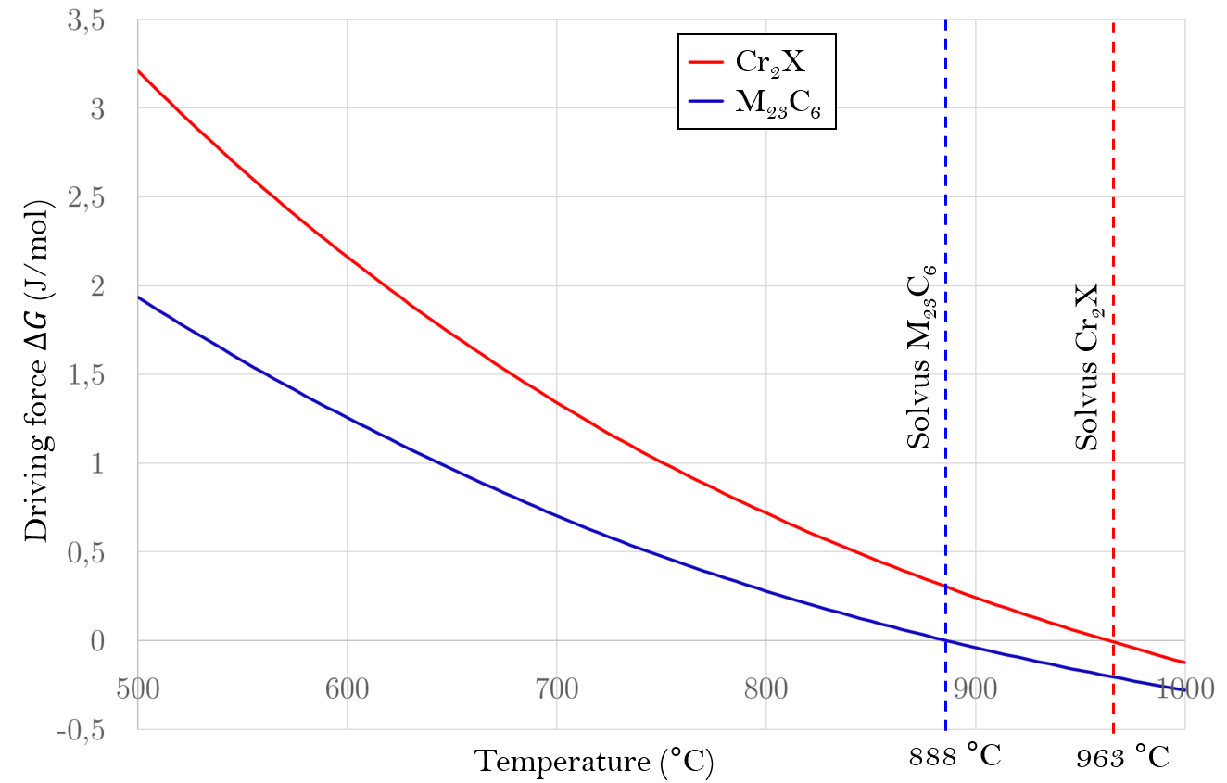

Figure 16 : Driving force for chromium carbides and nitrides precipitation as a function of temperature calculated with Thermo-Calc TCFE10

We are now studying the growth of a germ during quenching using DICTRA software. Since Cr2X are the most likely phase to form, we will only be interested in the growth of this phase, governed by the diffusion of elements in the lattice, from a 1 nm seed of thickness in intergranular position present at time t=0 of calculation. The DICTRA calculation assumptions describe the intergranular precipitation with a spherical geometry of one dimension. The calculation box has the dimension of the mean radius of the grains and is composed of two regions: the ferritic matrix and a seed of Cr2X (phase HCP_A3#2) of thickness 1 nm which lines the sphere in order to simulate the intergranular growth of the Cr2X phase (the germ is shown in green on the diagram in Figure 17). The interface between the matrix and the precipitate is of zero thickness. The composition varies discontinuously on either side of the interface. The interface is infinitely mobile, which means that thermodynamic equilibrium applies to the interface. This local equilibrium indicates that the compositions on either side of the interface are given by a conode of the phase diagram.

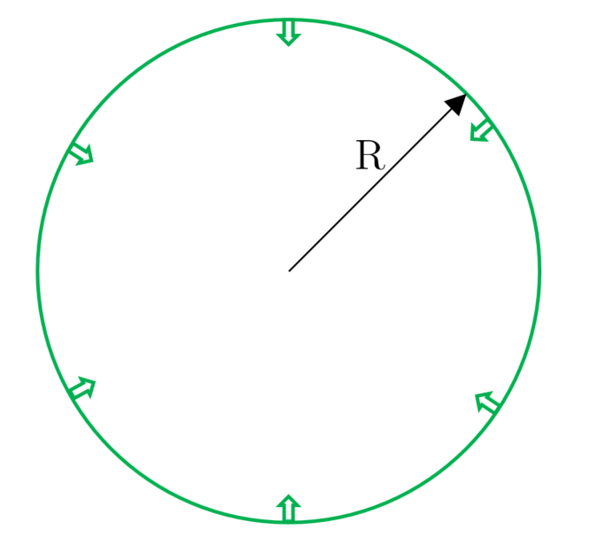

Figure 17 : Diagram illustrating the germ from the DICTRA calculation, a film on the surface of the calculation box whose radius R is 125 µm

The growth calculation is carried out from 1050 ° C (initial temperature) down to 700 ° C, temperature below which the reaction is kinetically blocked. The starting temperature was chosen equal to the temperature of the recrystallization heat treatment applied to the Cr0 microstructure (1050 ° C. / 10 min / water quenched). The cooling rate is estimated from the abacus of Figure 18. The thickness of the bars during the recrystallization heat treatment is 12.5 mm. We use the water quenching cooling curve for a part with a diameter of 10 mm to estimate the cooling rate: in 7 seconds, the temperature of the part decreases from 750 ° C to 100 ° C, i.e. on average a cooling rate of about -100 °C/s. This order of magnitude seems appropriate for DICTRA calculations.

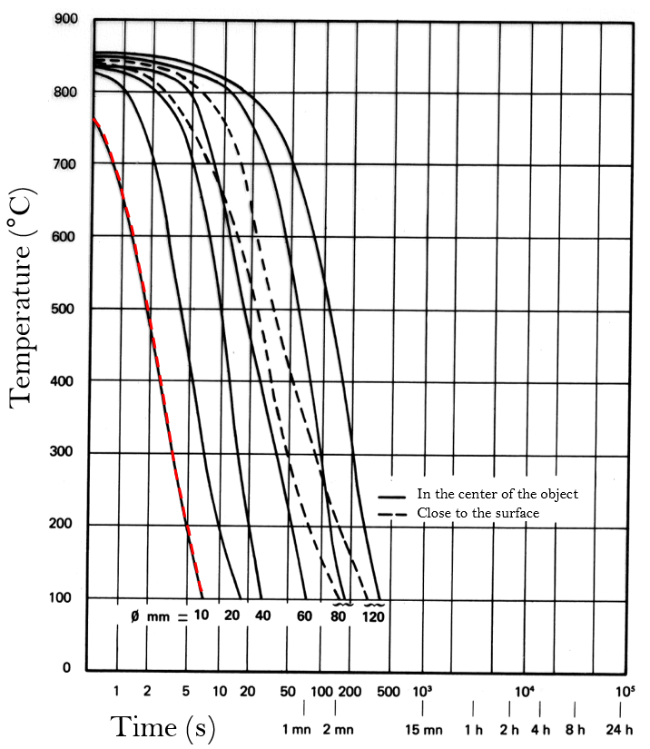

Figure 18 : Continuous cooling curves depending on the size of the part during water quenching [20].

The chemical composition of the Cr1 heat is simplified to the elements of primary importance which drive the precipitation of Cr2X. The calculations were carried out initially with a mother phase of uniform composition with 18% chromium, 2% of molybdenum, 0.017% nitrogen and the balance of iron (composition N) then in a second step with a mother phase of composition 18% chromium, 2% molybdenum, 0.017% nitrogen, 0.012% carbon and the iron residual (composition N + C). The growth of the germ during cooling is given in Figure 19. It is noted that the growth begins only at 960 ° C, temperature from which the precipitation of the Cr2X phase becomes stable. From around 750 ° C, the thickness of the precipitates remains more or less constant because the precipitation is gradually limited by the diffusion for lower temperatures, which justifies stopping the calculations at 700 ° C.

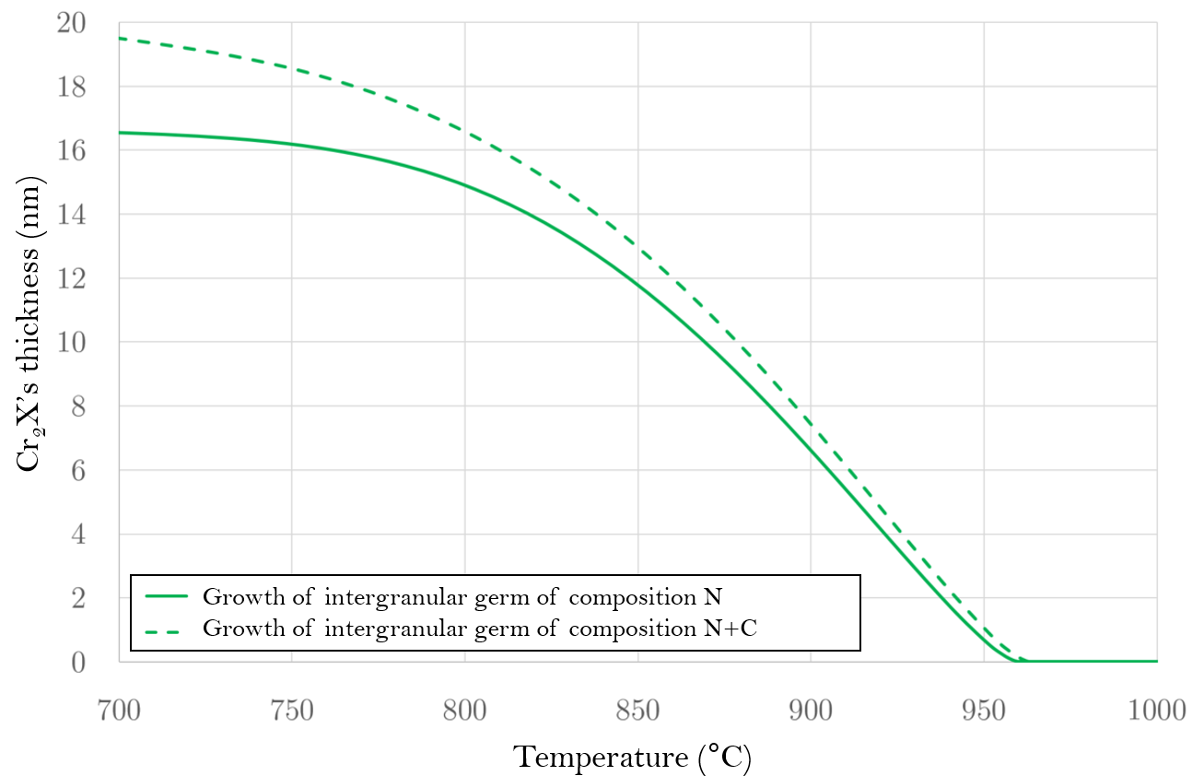

Figure 19 : Thickness of the germ during cooling on either side of the grain boundary.

At grain boundary, the film thickening predicted by the diffusive growth model is 17 nm with composition N, almost 20 nm with composition N + C, assuming that the film grows on either side of the grain boundaries. The addition of carbon only slightly modifies the thickness of the precipitation because the X of Cr2X mainly denotes nitrogen (there is about 4 times more nitrogen than carbon in Cr2X at 800 °C based on the metastable equilibrium calculation). These dimensions are close to the mean diameter of 30 nm of the intergranular particles measured experimentally with TEM for the Cr0 microstructure.

The chromium, molybdenum and nitrogen diffusion profiles upstream of the interface following rapid cooling are shown in Figure 20 during intergranular growth.

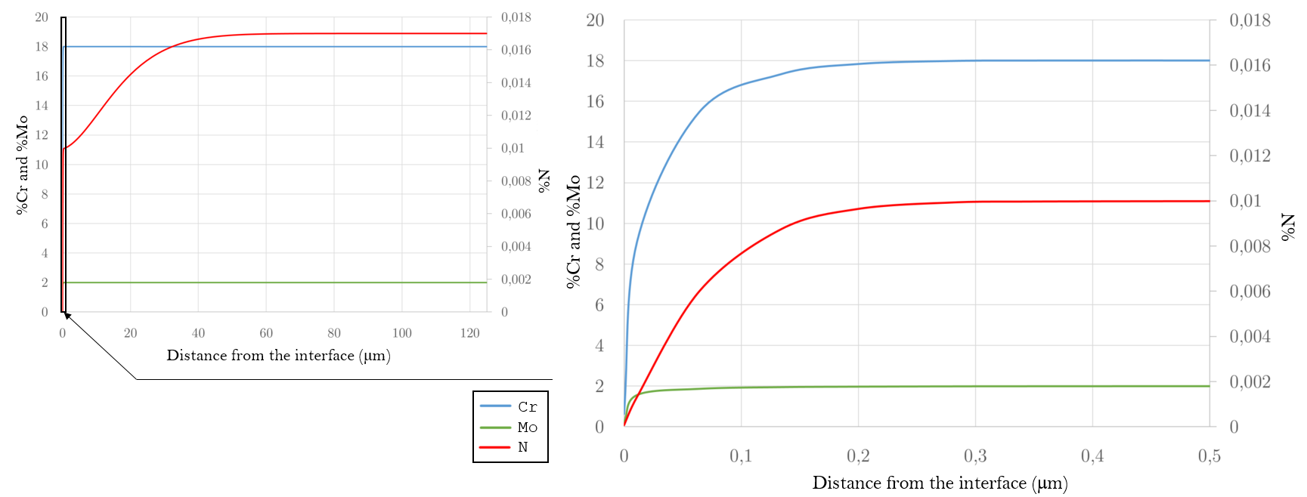

Figure 20 : Cr, Mo and N contents in ferrite at 700 °C upstream of the interface following the growth of the intergranular germ with the composition N.

During the growth of the intergranular germ, the nitrogen profile presents a "double aspect" which is explained by:

* A strong gradient, close to the interface and which extends over a width of approximately 200 nm. This gradient is linked to the interaction with chromium, a low mobility element which necessarily exhibits a high gradient at the interface to feed the growth of the precipitate.
* A much weaker gradient, at long distance (over about forty micrometers), which ensures the nitrogen flow necessary for the growth of the precipitate.

This interpretation becomes clearer when considering the nitrogen activity which directly governs chemical diffusion, and does not present a high gradient near the interface. By integrating the nitrogen profile along the radius of the grain, the nitrogen content in the ferrite is determined following a -100 °C/s cooling rate. The nitrogen content, initially 0.017%, is equal to 0.014% after cooling. Figure 21 shows the evolution of the volume fraction of Cr2N at the grain boundaries as a function of the temperature during water quenching. By comparison with the expected volume fraction if the thermodynamic equilibrium is respected, it is noted that the growth of an intergranular germ can only capture 10% of the nitrogen present in solid solution during the water quenching. A volume fraction hardly greater would be expected for the N + C composition. This result is in agreement with our experimental observations: only 10% of the volume fraction of Cr2N expected if the thermodynamic equilibrium is respected was observed at the grain boundaries. In addition, it is understood that for the nitrogen and carbon to precipitate entirely during the water quenching, intragranular precipitation is essential.

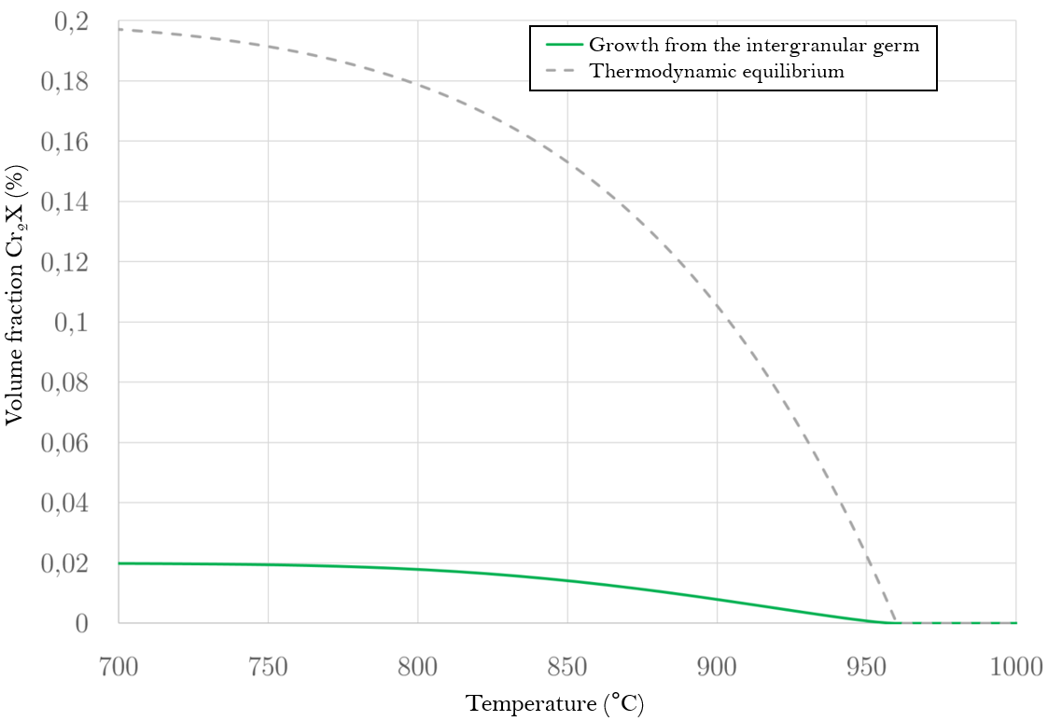

Figure 21 : Estimation of the volume fraction of during cooling by water quenching during the growth of the germ in intergranular conditions, calculation with the composition N. Comparison with the volume fraction of at equilibrium.

The thermodynamic calculations carried out with the Thermo-Calc software and the DICTRA module have shown that Cr2X are the precipitates most prone to form during cooling. Moreover, according to these calculations, dThose numerical results are in agreement with our experimental observations: the precipitates mainly present in the Cr0 microstructure are Cr2X and the thickness of the particles in the grain boundaries is about thirty nanometers. Thus, from our calculations, we can conclude that, during water quenching, the proportion of nitrogen and carbon which precipitate at the grain boundaries represents only about 10% of their nominal content.

In order determine if C + N remains in solid solution, Table 4 groups together the volume fractions estimated previously for the Cr0 microstructure from SANS measurements as well as the intergranular precipitation volume fraction, for which the numerical calculation and the estimate from TEM image analysis gave the same value. Without concluding on the nature of the precipitation quantified with neutron scattering, we notice that the sum of the volume fraction of the intergranular Cr2X precipitates and of the volume fraction of the precipitates quantified with the neutron scattering (whatever the precipitation assumption) is far less than the volume fraction of precipitates at metastable equilibrium, as calculated with ThermoCalc software.

|  |  |  |  |  |  |
| --- | --- | --- | --- | --- | --- |
| Intergranular precipitation (MET) | | Precipitation quantified with the SANS | | Precipitation at metastable equilibrium at 600 °C (with Thermo-Calc) | |
| Cr2(N,C) | 0.02% |  | 0.02 à 0.027% |  | 0.34% |
|  | 0.012 à 0.032% |  | 0.24% |
| MX | 0.05 à 0.072% | MX | 0.17% |

Table 4: Estimated or calculated volume fraction for microstructure Cr0

Thus, for the Cr0 microstructure, assuming that the assumptions made to estimate the volume fractions of particles are correct, either a precipitation containing carbon and nitrogen has not been quantified, or carbon and nitrogen remain in solid solution in supersaturation at room temperature. The difference between the expected volume fraction of precipitates and the one estimated here is at least 0.1%. Moreover, since we used increasingly sophisticated characterization tools, allowing the study of finer and finer precipitates, down to the nanometer, the precipitation of the Cr0 microstructure was particularly studied. So, we conclude that a significant amount of carbon and nitrogen remains in solid solution, from 30% to 80% of the initial amount, depending on the nature of the precipitation quantified with the neutron scattering. [21] and [11] explained that with a heat treatment to re-dissolve the chromium carbides and nitrides followed by water quenching, the grain boundaries of ferritic stainless steels are free from precipitates. The deployment and improvement of characterization tools since the publication of their articles have enabled us to conclude the opposite by observing nanometric precipitation thanks to TEM and SANS.

For the Cr microstructure, the same approach is more complex to apply because many precipitates are present in the grains with micrometric sizes for which it is difficult to give an estimate of the volume fraction (Figure 11). In this case, the sum is of the same order of magnitude as the theoretical volume fraction determined using Thermo-Calc software with .

Nevertheless, in the CrP microstructure, the precipitates are more numerous and larger than in Cr microstructure. Yet, the heat treatment at 850 °C, which distinguishes the CrP microstructure from the Cr, allows the precipitation of carbon and nitrogen but without prior dissolution. The precipitates observed in the CrP microstructure certainly come from the reorganization of existing precipitates (coalescence) and also from new seeds formed with carbon and nitrogen still present in the interstitial space before the heat treatment at 850 °C. In addition, the elastic limit of the Cr microstructure is 100 MPa greater than that of the CrP: this difference cannot be explained by grain size effect since grain have similar size in both microstructures (Table 5); neither by precipitation effect since precipitates are more numerous in CrP. Thus, the presence of carbon and nitrogen in supersaturated solid solution certainly justifies these differences in microstructural and mechanical properties.

|  |  |
| --- | --- |
| Unstabilized microstructre | Yield strength at 25 °C |
| CrP | 338 ± 1 MPa |
| Cr | 450 ± 10 MPa |
| Cr0 | 539 ± 5 MPa |

Table 4 : Yield strength, determined by tensile tests at room temperature, for the three unstabilized microstructures

# Conclusions

This first article devoted to the study of brittle fracture by cleavage in ferritic stainless steels with 18% Cr and 2% Mo focused on the development and characterization of six model microstructures, for which the grain size, the nature and size of the precipitates and the presence of C + N in solid solution change. Figure 22 summarizes the main characteristics of each microstructure (oxides, present in every microstructure are not represented). For Nb and Ti microstructures the matrix and the grain size are comparable and only the nature and size of precipitates differ. The grains in the NbG microstructure are 10 times larger than those in the Nb microstructure for the same type of precipitation. The Nb (C, N) are slightly larger in the NbG microstructure. The CrP and Cr microstructures have the same grain size (common with the Nb and Ti microstructures) but the heat treatment at 850 °C for CrP modifies the state of precipitation: the precipitates are more numerous and larger than in Cr microstructure. For the Cr0 microstructure, and to a lesser extent the microstructure Cr, we have observed that after a dissolution heat treatment at xxx°C followed by water quenching, despite the high rate of cooling, chromium carbides and nitrides precipitate. However, a major part of the C+N remain in solution in the ferrite at room temperature and harden the ferritic matrix.

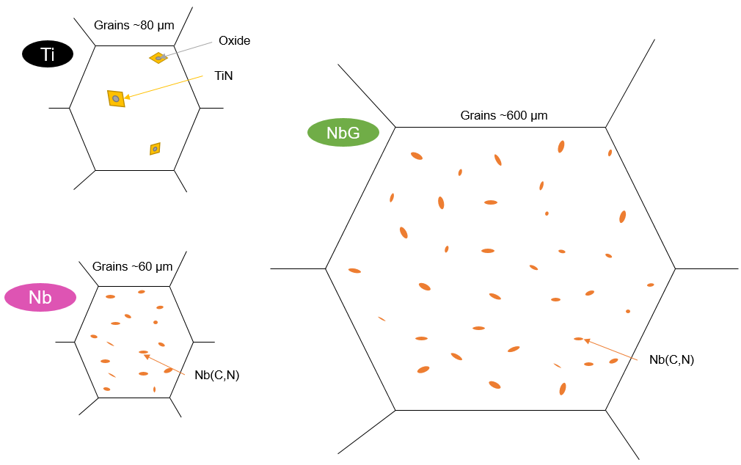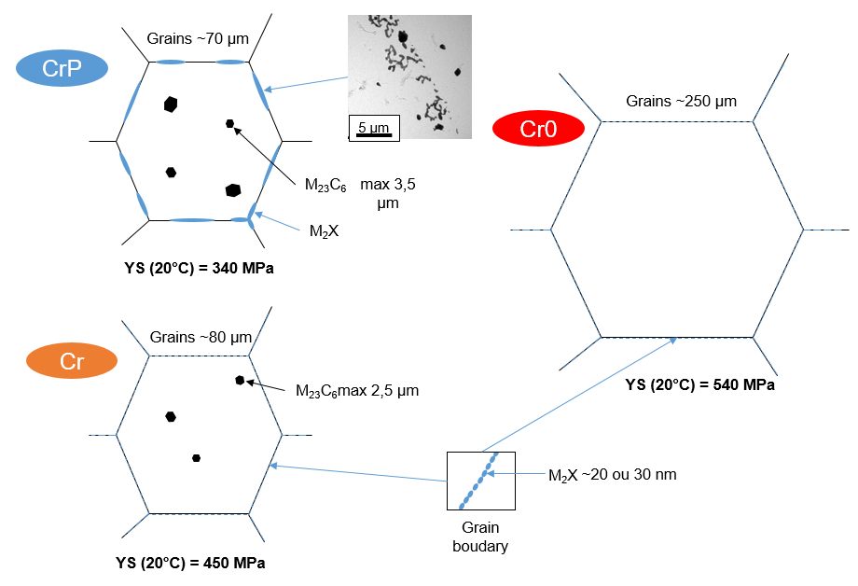

Figure 22 : Schemes of one grain for each microstructure

Part II of this article will focus on the mechanical properties and brittle fracture by cleavage of these six microstructures.

# Acknowledgements

The authors are grateful for the financial support of Ugitech and SIMaP Grenoble INP. Moreover, the authors would like to thanks all researchers and technicians of the SIMaP laboratory and the Ugitech’ research center and in particular Pierre Chemelle for his help to characterize the microstructures. In addition, we would like to thanks Ralf Schweins and the rest of the staff of the ILL for their help during the SANS experiment ([http://dx.doi.org/10.5291/ILL-DATA.1-01-177](https://antiphishing.vadesecure.com/v4?f=RkdqNzdIQkFjZzVZTkZxbYuxHnUahi8x-bBMC8gyTD-52TX5w09c7hC305CMT5pKIxrTc1y8PehPFYmpaeN_WA&i=ZUcyY1RmWEJYTXg4endZcd0IOop0ZEpo_GuFrOVoavU&k=YkLs&r=N3ZnQkVkbG1hOHVwcWFJNO_4cD4O9AshsIFXTrxtdhngzRmtGjNGEhAaYE13y7ue&s=cf6383b38e794b422a5f20cfb5460cf54289b3450a21b6c05875d1f69f541a03&u=http%3A%2F%2Fdx.doi.org%2F10.5291%2FILL-DATA.1-01-177)).

# Bibliography

[1] P.-J. Cunat, J. Charles, L’acier inoxydable, d’un siècle à l’autre, La Rev. Métallurgie. 101 (2004) 971–986. https://doi.org/https://doi.org/10.1051/metal:2004182.

[2] B. Baroux, Les aciers inoxydables ferritiques à 17%Cr, in: Les Aciers Inox., Les éditions de physique, 1990: pp. 519–549.

[3] M. Durand-Charre, La microstructure des aciers et des fontes, Springer, 2003.

[4] B. Tanguy, Modélisation de l’essai charpy par l’approche locale de la rupture : application au cas de l’acier 16MND5 dans le domaine de transition, Thèse de doctorat Ecole des Mines de Paris, 2004.

[5] F. Tioguem, M. Maziere, F. Tankoua, A. Galtier, Identi fi cation of ductile to brittle transition temperature by using plane strain specimen in tensile test and correlation with instrumented Charpy impact test : experimental and numerical study, 107 (2018).

[6] H. Godin, J.-D. Mithieux, C. Parrens, G. Badinier, M. Sennour, A.-F. Gourgues-Lorenzon, Effects of cooling path and resulting microstructure on the impact toughness of a hot stamping martensitic stainless steel, Mater. Sci. Eng. A. 742 (2019) 597–607. https://doi.org/10.1016/j.msea.2018.11.036.

[7] F.M. Beremin, A local criterion for cleavage fracture of a nuclear pressure vessel steel, Metall. Trans. A. 14 (1983) 2277–2287. https://doi.org/10.1007/BF02663302.

[8] J. Saleil, M. Mantel, J. Le Coze, La production des aciers inoxydables Histoire de son développement et des procédés de fabrication. Partie II. Évolutions de l’élaboration des aciers inoxydables au four électrique à arc. La tentation de la fonte au chrome et la production d’aciers inoxyda, Matériaux Tech. 108 (2020) 104. https://doi.org/10.1051/mattech/2020017.

[9] B.C. De Cooman, Lectures on Stainless Steel, in: 2016. https://doi.org/10.13140/RG.2.1.1163.8161.

[10] M. Sarkari Khorrami, M.A. Mostafaei, H. Pouraliakbar, A.H. Kokabi, Study on microstructure and mechanical characteristics of low-carbon steel and ferritic stainless steel joints, Mater. Sci. Eng. A. 608 (2014) 35–45. https://doi.org/10.1016/j.msea.2014.04.065.

[11] H. Abo, T. Nakazawa, S. Takemura, M. Onoyama, H. Ogawa, H. Okada, The role of carbon and nitrogen on the toughness and intergranular corrosion of ferritic stainless steels, Stainl. Steel ’77. (1977) 35–47.

[12] H. Sassoulas, Traitements thermiques des aciers inoxydables, Tech. l’ingénieur. ASTM M 115 (1997). https://doi.org/10.1051/metal/191007070489.

[13] A. Ostrowski, E.W. Langer, Precipitation of titanium carbonitrides in as-cast 17% chromium stainless steels, Scand. J. Metall. 8 (1979) 153–160.

[14] J.D. Redmond, Toughness of 18Cr-2Mo stainless steel.pdf, Toughness Ferritic Stainl. Steels. (1980) 123–144.

[15] M. Mantel, Baroux, Ragot, P. Chemelle, Relation entre la microstructure et la résistance au fluage et à l’oxydation d’aciers à 17% de chrome stabilisés par du zirconium et du niobium, Mémoire Études Sci. Rev. Métallurgie. (1990) 637–648.

[16] M.P. Sello, W.E. Stumpf, Laves phase embrittlement of the ferritic stainless steel type AISI 441, Mater. Sci. Eng. A. 527 (2010) 5194–5202. https://doi.org/10.1016/j.msea.2010.04.058.

[17] P. Chemelle, D. Henriet, Mise en solution et précipitation des carbonitrures de Titane et de Niobium dans les aciers ferritiques stabilisés, 1984.

[18] F. Perrard, Caractérisation et modélisation de la précipitation du carbure de niobium et du cuivre dans les aciers bas carbone, Institut Naional Polytechnique de Grenoble, 2004.

[19] O. Tissot, C. Pareige, M.H. Mathon, M. Roussel, E. Meslin, B. Décamps, J. Henry, Comparison between SANS and APT measurements in a thermally aged Fe-19 at.%Cr alloy, Mater. Charact. 151 (2019) 332–341. https://doi.org/10.1016/j.matchar.2019.03.027.

[20] IRSID, Atlas des courbes de transformation des aciers de fabrication française, 1974.

[21] A.C.T.M. Van Zwieten, J.H. Bulloch, Some considerations on the toughness properties of ferritic stainless steels-A brief review, Int. J. Press. Vessel. Pip. 56 (1993) 1–31. https://doi.org/10.1016/0308-0161(93)90114-9.